**Name _____Paul Briery___________**

**Temple College**

**Fall DC Assignment #2**

**VNSG 1460: Clinical – LVN Training II**

**Round to the nearest tenth. All answers are per dose.**

1. The health care provider order reads to give the client Ceclor 200 mg po every 8 hours. According to the following label, how many mL would you give the client per dose?

____2.7___200/375=53.33_5-%53.33= 2.66____________

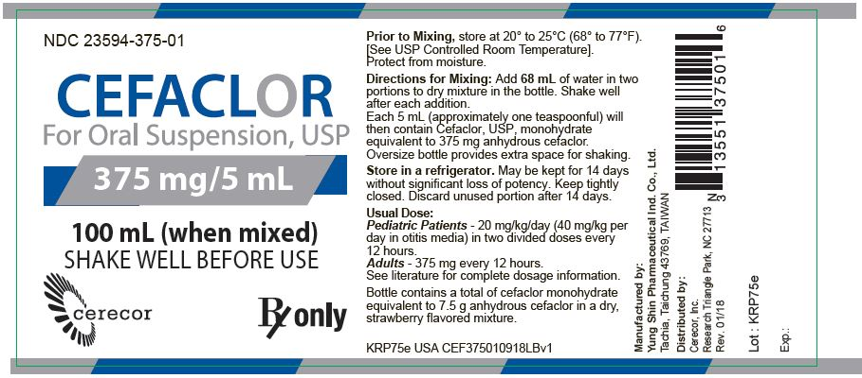

1. The client is scheduled to receive OxyFast 25 mg po at 0800. According to the following label, how many mL would you give the client?

Give: __1.3___25/20=1.25_______________

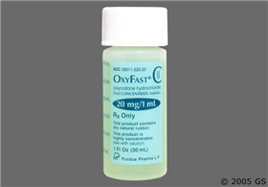

1. Desired: Heparin 4,000 units SC every 8 hours

According to the following label, how many mL would you give per dose? _4___ 4k/1k=4 _______________

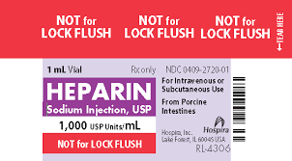

1. Your client is complaining of abdominal pain. The health care provider has ordered Ketorolac 18 mg IM every 6 hours prn pain. You have Ketorolac 60 mg per 2 mL available.

How many mL would you give per dose?__0.6 ___18/60=.3 0.3x2=0.6______________

1. Desired: Morphine 3 mg every 2 hours prn pain.

According to the label below, how many mL would you give per dose? __0.6___3/5=.6_______________

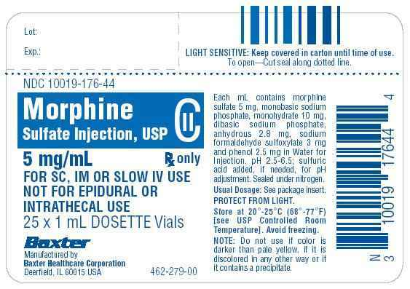

1. The health care provider has ordered Penicillin G Procaine 1,200,000 units IM every other day. You have on hand Penicillin G Procaine 600,000 units/mL.

How many mL will give per dose? ____2______1.2m/600k=2__________

1. Desired: Valium 3mg IM every 6 hours

Available: Valium 10 mg/2 mL

How many mL will you give per dose? __0.6____3/10=.3 .3x2=.6__________

**Round to the nearest whole number.**

1. A cholecystectomy client is to receive 1250 mL of Lactated Ringers (LR) over 12 hours.

Drop Factor: 20 gtt/mL

1. How many mL/hr? __104____1250/12=104.1_____________
2. How many gtt/min? __35____60/20=3 104/3=34.66_____________
3. The health care provider orders 1000 mL of LR solution to infuse over 1 hour for a postoperative client who has undergone a Whipple’s procedure. Drop factor: 10gtt/mL
4. How many mL/hr? ____1000_____1000/1___________
5. How many gtt/min? __167_________60/10=6__1000/6=166.6______
6. Your client is receiving 50 mL of IVPB antibiotics over 45 minutes for cellulitis.

Drop Factor: 60 gtt/mL

1. How many mL/hr? ____67_______50/45=1.11*60=66.6________
2. How many gtt/min? ___67_______50/45=1.11*60=66.6________